|  |  |
| --- | --- |
|  | **FPT SOFTWARE** |

Indie Vibe

Test Plan

Project Code: IVB

Document Code: IVB_TestPlan_v1.1

**Hanoi, Jan 2021**

Record of change

*A - Added M - Modified D - Deleted

|  |  |  |  |  |
| --- | --- | --- | --- | --- |
| Effective Date | Changed Items | A* M, D | Change Description | New Version |
| 01/25/2021 |  | A | Create New | 1.0 |
| 12/3/2021 |  | M | Change Test plan features | 1.1 |
|  |  |  |  |  |
|  |  |  |  |  |
|  |  |  |  |  |
|  |  |  |  |  |
|  |  |  |  |  |
|  |  |  |  |  |
|  |  |  |  |  |
|  |  |  |  |  |
|  |  |  |  |  |
|  |  |  |  |  |
|  |  |  |  |  |
|  |  |  |  |  |
|  |  |  |  |  |
|  |  |  |  |  |
|  |  |  |  |  |
|  |  |  |  |  |
|  |  |  |  |  |
|  |  |  |  |  |
|  |  |  |  |  |

SIGNATURE PAGE

**ORIGINATOR:** Pham Tien Dat Jan 25, 2021

Quality Assurance

Vu Tien Khoi Jan 25, 2021

Tester

Nguyen Khuong Quan Jan 25, 2021

Tester

Trinh Ba Minh Ninh Jan 25, 2021

Test Leader

**REVIEWERS:** Trinh Ba Minh Ninh Jan 30, 2021

Test Leader

**APPROVAL:** Pham Duc Thang Jan 31, 2021

Project Manager

TABLE OF CONTENTS

1 INTRODUCTION 5

1.1 Purpose 5

1.2 Background information 5

1.3 Scope of testing 5

1.4 Test Approach 6

1.5 Constraints 7

1.6 Risk list 7

2 Requirements for Test 7

2.1 Functional Items 7

3 TEST STRATEGY 8

3.1 Test types 8

1. Functional Testing 8

2. User Interface testing 9

3.1 Test stage 10

3.2 Tools 10

4 RESOURCE 11

4.1 Human Resource 11

4.2 System 11

5 TEST MILESTONES 12

6 DELIVERABLES 12

# INTRODUCTION

## Purpose

The test plan contains a detailed understanding of the workflow and functions of the system and documents how each of those will be tested to find out if the system works as its design, to find bugs, and to address its limits. The content of this chapter will help developers and testers to work together to make sure that the system is completely tested, and functions as intended.

This is the comprehensive test plan of the Indie Vibe project. The purpose of the document describes scopes of test and activities which need to be taken during test process of project. It addresses the following items:

|  |  |
| --- | --- |
| * Scopes of Testing * Requirements for Testing * Test Strategy | * Test Resources * Test Milestones * Test Deliverables |

## Background information

Nowadays, streaming services have become widespread on The Internet. Before streaming technology became popular, to access entertainment content like music and movies, people had to buy physical copies or wait hours to download. With the introduction to the streaming services, now people can access media content in real-time from anywhere and anytime with just an Internet connected device. Furthermore, these streaming services have brought with some amazing additional features like sharing, content suggestion. In turn, they also help content creators easily introduce their content to the right audience.

## Scope of testing

|  |  |  |
| --- | --- | --- |
| No. | Test Level | Description |
| 1 | Unit Test | Unit Tests are performed by developers to ensure that individual units of source code function as intended. Unit tests are primarily used to test complicated algorithms and automatically test important functions. |
| 2 | Integration Test | Integration Tests are performed by testers to test whether a combined unit function as intended. We also know defects between the modules/functions. After that, the developer will fix the system suitably. |
| 3 | System Test | System Tests are performed by testers. To test the system as a whole and determine whether the system meets the requirements. |

The scope of test will be limited to testing two application: the HTML 5 applications and Android.

## Test Approach

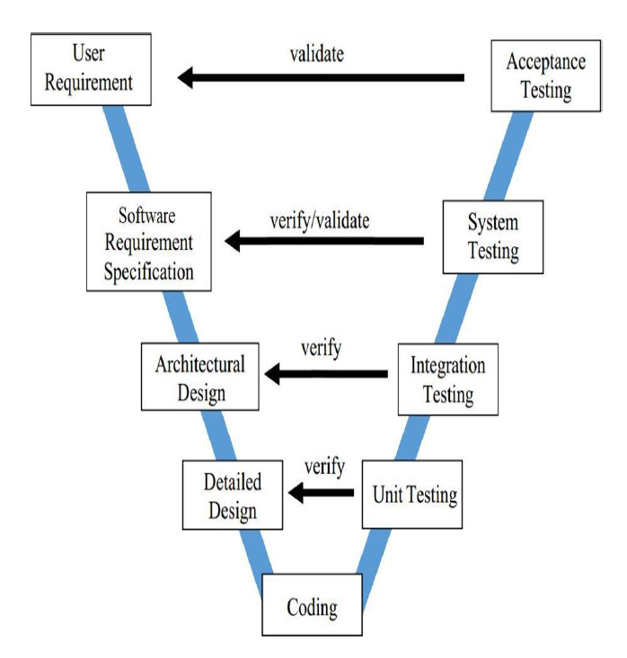This project follows the V Models to implements testing.

## Constraints

The following constraints may apply when testing is performed on system:

* Deadline for testing only can be met if development progress is on time
* Test execution can be performed when system passes Unit Test Inspection
* At least one round of testing must be performed for requirements

## Risk list

| # | Description | Source | Probability | Exposure | Trigger |
| --- | --- | --- | --- | --- | --- |
| 1 | Depends on the UI design and requirement documents from Indie Vibe | Critical Dependencies | 0.7 | 5.6 |  |

# Requirements for Test

## Functional Items

|  |  |
| --- | --- |
| 1. Authentication - Login 2. Authentication – Logout 3. Streaming - View playback control 4. Streaming - Play track 5. Streaming - Play list 6. Streaming - Add to queue 7. Library Management - Add to library 8. Library Management - Remove from library 9. Library Management - View profile 10. Library Management - Follow 11. Library Management - Unfollow 12. Library Management - Add to favorite 13. Library Management - Remove from favorite 14. Library Management - View library 15. Browse - View home 16. Browse - Search 17. Browse - View browse 18. Account Management - Update password 19. Account Management - View settings 20. Account Management - Fixed premium 21. Account Management - Change audio quality 22. Account Management - View account 23. Account Management - Edit account details 24. Account Management - Monthly premium 25. Account Management - Cancel subscriptions 26. Account Management - Become an artist 27. Playlist Management – Remove from Playlist 28. Playlist Management – View Playlist 29. Playlist Management – View Playlist Quick Access 30. Playlist Management – Set Playlist Privacy 31. Playlist Management – Delete Playlist 32. Playlist Management – Add to Playlist | 1. Playlist Management – Edit Playlist Details 2. Release Management – View Release 3. Release Management – View List Release 4. Workspace Management – Update Release Detail 5. Workspace Management – Update Release Detail 6. Workspace Management – Update Release Song 7. Workspace Management – Update Release Privacy 8. Workspace Management – Delete Release 9. Workspace Management – Upload Release 10. Workspace Management – Delete Song 11. Workspace Management – Add Song to Release 12. Workspace Management – View Statistic 13. Artist Management – View Artist 14. Artist Management – Report Artist 15. CMS – Login to CMS 16. CMS – View pending Artist request 17. CMS – Approve Artist request 18. CMS – Search simple users 19. CMS – Delegate curator 20. CMS – View list report artist requests 21. CMS – Verify report artist requests 22. CMS – View stream statistics   CMS – View revenue |

# TEST STRATEGY

## Test types

### Functional Testing

Functional testing is a formal type of testing performed by testers. Functional testing focuses on

testing software based on software requirement document, the functional use cases and design

document. Test Objective:

|  |  |
| --- | --- |
| Test Objective: | Checking the functionalities of the software system. It mainly concentrates on:  - Mainline functions  - Basic Usability  - Accessibility  - Error Conditions |
| Technique: | Execute each use case, use-case flow, or function, using valid and invalid  data which is identified by understanding the Software Engineering  Requirements to verify the following:  - The executed results occur when valid and invalid data is used.  - Valid input data is updated correctly into database.  - The appropriate error or warning messages are displayed when invalid data is used.  - Each business rule is properly applied. |
| Completion Criteria: | -   All planned tests have been executed.  -   All identified defects have been addressed.  - The appropriate activities will be performed when valid data is used  - The corresponding error/warning message mechanism is applied for each specific case  - All bugs found must be fixed |
| Special Considerations: | N/A |

### User Interface testing

 User interface testing, a testing technique used to identify the defects in design of Graphical user Interface (GUI)

|  |  |
| --- | --- |
| Test Objective: | Verify the following:  - Navigation through the target-of-test properly reflects business functions and requirements, including window-to-window, field-to-field, and use of access methods (tab keys, mouse movements, accelerator keys).  - Window objects and characteristics, such as menus, size, position, state, and focus conform to standards |
| Technique: | Create or modify tests for each window to verify proper navigation and object states for each application window and objects.  - Manual Based  - Capture and Replay  - Model-based Testing  - Testers execute test based on test scenarios and create report. Common defects will be collected for improved checklists.  - Execute each case, using valid, invalid and boundary data, to verify the expected results display when valid, invalid and boundary data is used. |
| Completion Criteria: | Each window successfully verified to remain consistent with benchmark version or within acceptable standard.  - Check screen validations  - Verify all navigations  - Check usability conditions  - Verify the object states  - Verify the date field and numeric field formats |
| Special Considerations: | Not all properties for custom and third-party objects can be accessed. |

### Data Validation Testing

Data Validation testing is a process that allows the user to check that the provided data, they deal with, is valid or complete.

|  |  |
| --- | --- |
| Test Objective: | Checking data that the entered data valid or not according to the provided business conditions. It mainly concentrates on:  - Data Format  - Data Type  - Data Value |
| Technique: | Execute each use case of entered data, using valid, invalid and boundary  data which is identified by understanding the Software Engineering  Requirements to verify the following:  - The executed results occur when valid and boundary data is entered.  - The appropriate error or warning messages are displayed when invalid data (wrong format, wrong data type, out of range of value) is entered.  - Each business rule is properly applied. |
| Completion Criteria: | -   All planned tests have been executed.  -   All identified defects have been addressed.  - The expected result or expected screen will be displayed when valid and boundary data is entered.  - The corresponding error/warning message mechanism is applied for each specific case. |
| Special Considerations: | N/A |

## Test stage

| Type of Tests | Stage of Test | | | |
| --- | --- | --- | --- | --- |
| Unit | Integration | System | Acceptance |
| Functional Tests | x | x | x |  |
| GUI Test |  | x | x |  |
| Data Validation Test |  |  | x |  |

## Tools

|  |  |  |  |
| --- | --- | --- | --- |
| Purpose | Tool | Vendor/In-house | Version |
| Documenting | MS Word, Excel 365 | Microsoft | 2021 |
| Unit Testing | IntelliJ IDEA | JetBrains | 2020.3.1 |
| Function Testing | IntelliJ IDEA | JetBrains | 2020.3.1 |
| Use to test unit test case | Visual Studio Code + Junit plugin | Microsoft | 1.54 |
| Database | MySQL | Oracle | 5.7 |
| Used to test integration test case | Postman | Postdot Technologies | 8.0.7 |
| Used to view web pages, bug logging pages… | Chrome, Google Sheet | Google | 89 |

# RESOURCE

## Human Resource

This table shows the staffing assumptions for the project.

|  |  |  |
| --- | --- | --- |
| Worker/Doer | Role | Specific Responsibilities/Comments |
| Trinh Ba Minh Ninh | Test Leader, Developer | Review test cases and test report  Review overall quality of the project  Performing the actual system testing  Create test cases  Perform tests  Write test report  Log bugs |
| Nguyen Khuong Quan | Tester, Developer | Performing the actual system testing  Create test cases  Perform tests  Write test report  Log bugs  Create and perform unit test and integration test  Fix bugs |
| Vu Tien Khoi | Tester, Developer | Performing the actual system testing  Create test cases  Perform tests  Write test report  Log bugs  Create and perform unit test and integration test  Fix bugs |
| Pham Tien Dat | Project Technical Leader | Review Test Cases (UT, IT, ST)  Create and perform unit test and integration test  Fix bugs |

## System

The HTML5 web-based application and Android applications will require testing on the following iPhone and Android devices:

|  |  |
| --- | --- |
| Hardware | OS Version |
| Asus ExpertBook P3540 | Windows 10 64bit |

|  |  |
| --- | --- |
| Software | Version |
| Amazon Web Service | 2020 |
| MySQL Database | 5.7 |
| Spring Boot Framework | v2 |

# TEST MILESTONES

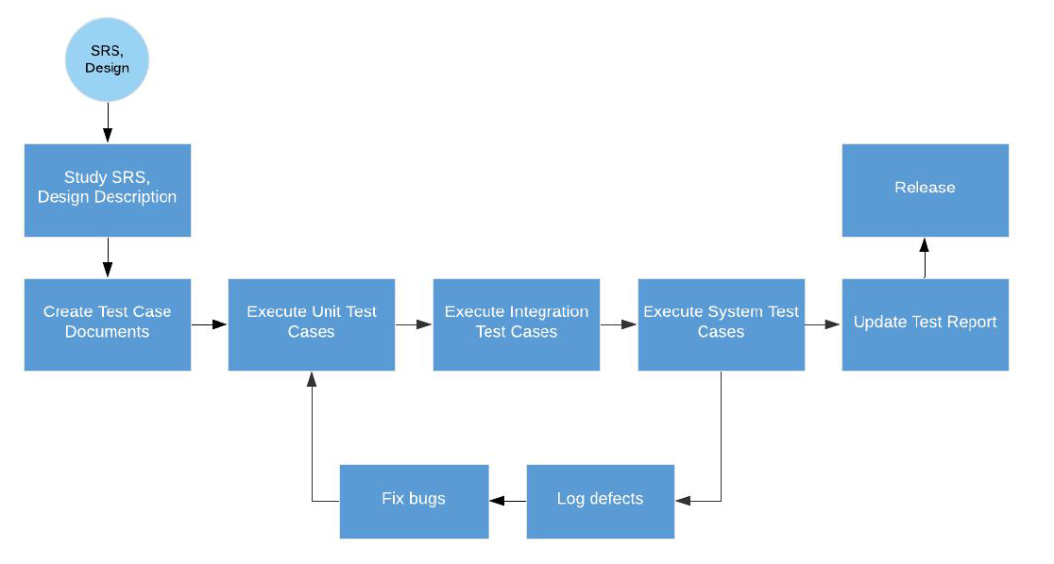

|  |  |  |
| --- | --- | --- |
| Milestone Task | Start Date | End Date |
| Unit Testing | 26/02/2020 | 8/04/2020 |
| Integration Testing | 02/03/2020 | 30/03/2020 |
| System Testing | 18/03/2020 | 16/04/2020 |

# DELIVERABLES

| No | Deliverables | Delivered Date | Delivered by | Delivered to |
| --- | --- | --- | --- | --- |
| 1 | Unit Test Case + System Test Case Release 1 | 28/03/2020 | Project Manager | Client |
| 2 | Unit Test Case +  System Test Case  Release 2 | 11/04/2020 | Project Manager | Client |
| 3 | Unit Test Case +  System Test Case  Release 3 | 25/04/2020 | Project Manager | Client |
| 4 | System Test case | 25/04/2020 | Project Manager | Client |
| 5 | Test Plan Documents | 25/04/2020 | Project Manager | Client |